INTERNAL AUDIENCE PERSONAS. INTERACTIVE TEMPLATE
COMPANY NAME:

Internal Audience personas will help you create profiles for your audience so you can use your research and knowledge to define the needs of individuals and groups in your workforce.

With the knowledge you have on your different demographics, check you have all the info in the checklist and fill in the table to help you visualise how your audience will consume the message and how you can deliver it. Rather than generalising areas of your workforce (e.g., office workers all have access to the intranet app outside of working hours) this formula helps to give you a more nuanced view.

There are a couple of examples to use as a point of reference. Please also take note that you can use this for demographics, work groups or pretty much anything you want to segment your audience into.

INTERNAL COMMUNICATION AUDIT PLANNING INTERACTIVE TEMPLATE
Research

Create a survey, poll or feedback form that can help determine how to best engage with your audiences matched up to their demographics, job type etc.

Make sure the questions are relevant and targeted at the groups you are asking. You may also want to make them anonymous so they can be more honest.
Your Findings

Write your findings here
E.g. 25% of warehouse workers do not like face-to-face meetings

What do you want to achieve from your audience research?
Write some key objectives here
E.g., Find out how to increase engagement rate of social content from desk workers

How are you going to measure it and who are you going to ask?
E.g., What percentage of workers 18-21 prefer to hear company news directly from leadership

Write your questions here

E.g., What type of social content do you engage with the most?

Creating Personas

Now you have the insights you need into the communication needs of your workforce you can create personas based on it. This will help to humanise the data and apply it to actual situations.

Our persona creation table will help conceptualise how certain demographics and groups will react to situations and the actions you can take from an internal comms perspective in order to get the desired outcome.

Here is an example for you to follow:

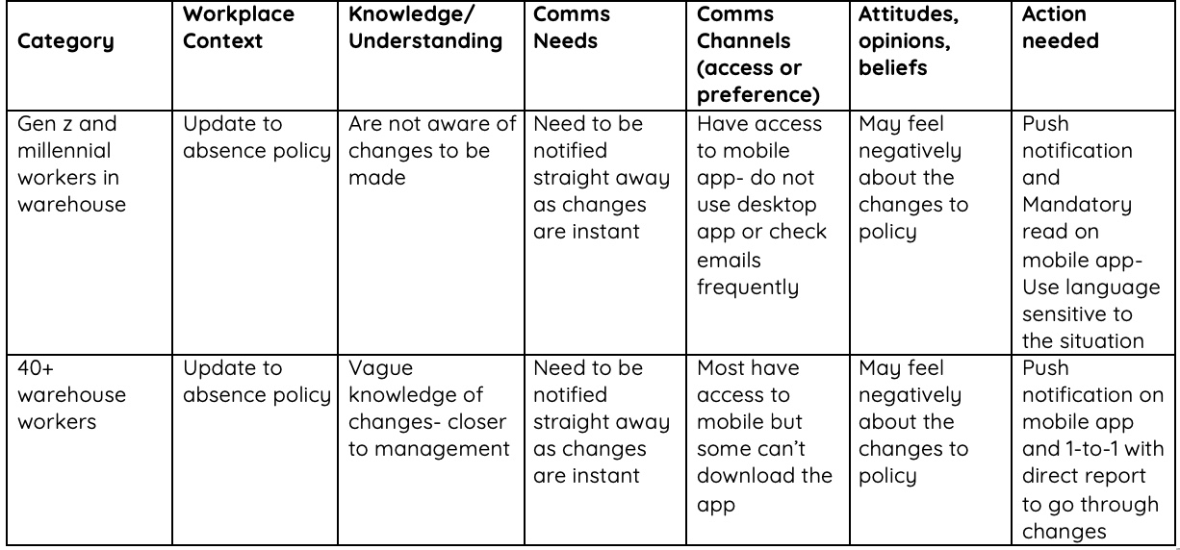

Now give it a go yourself:

Category | Workplace Context | Knowledge/  Understanding | Comms Needs | Comms Channels (access or preference) | Attitudes, opinions, beliefs | Action needed

See how Oak can transform your internal comms strategy: Book a demo
Talk to an expert

